For Immediate Release:

Rio enters international gastronomy circuit with cooking classes for international tourists
Five-hour course teaches easy Brazilian recipes
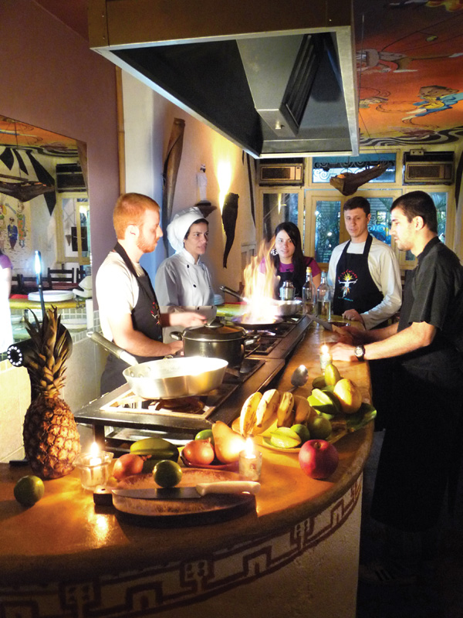
Rio de Janeiro- Brazil, October 6th 2009: You may not have heard of “batida de coco”, “aipim frito”, “moqueca” or “pé de moleque” but if you ask a Brazilian, they´ll explode about how flavorful they are. And with good reason: they are some of Brazil´s favorite foods and drinks that involve less than ordinary ingredients, such as cassava (manioc), sugar cane molasses, cashew fruit (not the nut) and dendê palm oil.
Entering the culinary travel market is “Cook In Rio”, Rio’s first cooking class designed for international travelers. The formula is similar to that offered in Thailand, where the tourist pays for a single class, cooks then eats.
“Brazil has a wide variety of ingredients and recipes, some of which can be easily recreated in Europe or the US, with simple substitutions on the hard-to-find ingredients.” Says Cristiano Lemos, marketing manager for Cook In Rio.
Lessons can be attended daily in Copacabana from 11am, lasting 5 hours, with up to 14 participants.
“We get everyone involved in the preparations and cooking, so everyone has fun.” He adds. “Plus we explain the origins and nutritional values of the exotic ingredients, as some are quite interesting.”

Contato: Cook In Rio : Cristiano Lemos / Simone Theisen info@cookinrio.com 21-8761-3653 www.cookinrio.com
###

